**ASSIGNMENT 1 FRONT SHEET**

|  |  |  |  |
| --- | --- | --- | --- |
| **Qualification** | **TEC Level 5 HND Diploma in Computing** | | |
| **Unit number and title** | **Unit 43: Internet of Things** | | |
| **Submission date** |  | **Date Received 1st submission** |  |
| **Re-submission Date** |  | **Date Received 2nd submission** |  |
| **Student Name** | Bùi Hương Linh | **Student ID** | GBH200662 |
| **Class** | GCH1002 | **Assessor name** | NgocLA |
| **Student declaration**  I certify that the assignment submission is entirely my own work and I fully understand the consequences of plagiarism. I understand that making a false declaration is a form of malpractice. | | | |
|  |  | **Student’s signature** | Linh |

**Grading grid**

|  |  |  |  |  |  |  |  |  |  |
| --- | --- | --- | --- | --- | --- | --- | --- | --- | --- |
| P1 | P2 | P3 | P4 | M1 | M2 | M3 | M4 | D1 | D2 |
|  |  |  |  |  |  |  |  |  |  |

|  |  |  |
| --- | --- | --- |
| **❒ Summative Feedback: ❒ Resubmission Feedback:** | | |
| **Grade:** | **Assessor Signature:** | **Date:** |
| **Internal Verifier’s Comments:** | | |
| **Signature & Date:** | | |

Table of Contents

Introduction 4

Task 1- Review and evaluate about IoT aspects. 4

I. IoT 4

1. Definition of IoT 4

2. How does IoT work? 5

3. Applications of IoT 5

4. IoT characteristics 5

5. Some examples for real world application of IoT 6

II. Review IoT functionality, standard architecture, frameworks, tools, hardware and APIs (P1-P2) 7

1. IoT architecture 7

2. IoT frameworks 9

3. API 9

4. IoT tools 10

5. IoT hardware 10

Task 2 – A specific program to solve using IoT 10

I. Problem 10

II. Solution 10

III. Components 11

Conclusion 13

References 14

Figure 1: IoT (Source: Internet) 4

Figure 2: Healthcare (Source: Internet) 7

Figure 3: Stage lot architecture 8

Figure 4: ESP32-CAM 11

Figure 5: Camera module OV2640-V1 12

Figure 6: FTDI 13

# Introduction

I'm currently work as a product developer for a new startup where you design IoT products for the consumer, corporate, government and defence clients. Your manager has tasked you with planning and developing a new IoT product, service, or application for a potential client. ou are required to identify a target user and conduct tests with this user and include this feedback into multiple iterative versions of your product.

# Task 1- Review and evaluate about IoT aspects.

1. IoT
2. Definition of IoT

The Internet of Things is a system of computer devices, machines, etc., or people that are related to each other, provided with a unique format and the ability to transmit data over a network without the need for human interaction. person-to-person or human-to-computer. IoT has evolved from the convergence of wireless technology, micromechanical technology, and the Internet. Simply put, it is a collection of devices that are able to connect to each other, to the Internet, and to the outside world to do a certain job.

(Gillis, 2022)

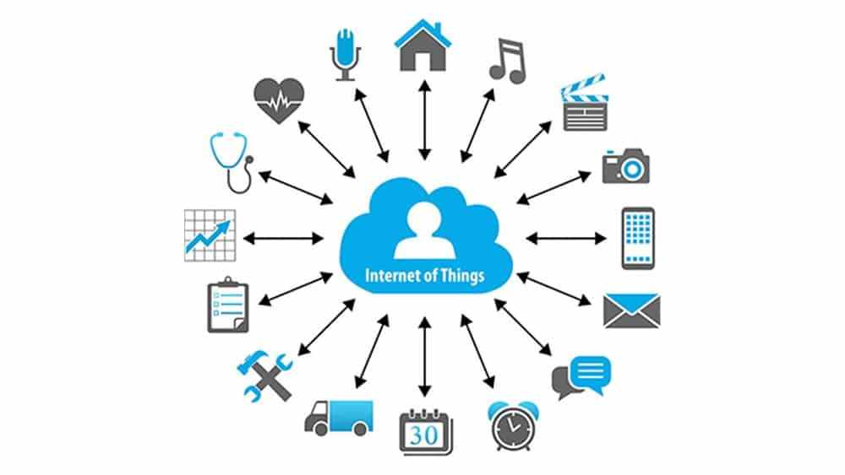

Figure 1: IoT (Source: Internet)

### How does IoT work?

Regardless of the field of application, a perfect IoT system must converge the steps: information collection, information sharing, information processing and decision making. The above processes are all performed by devices without human intervention. For fast, accurate data collection IoT can leverage AI or machine learning.

IoT can be objects, animals that are attached with processors, sensors, and hardware to collect all data in the environment in which they exist. Then the IoT devices send all the data to the cloud through connecting to the IoT gateway. When the data is stored in the cloud, it will be analyzed by the computer, processed and transferred to the human.

(Gillis, 2022)

1. Applications of IoT

The impact of IoT is very diverse in the fields of: infrastructure management, healthcare and automation, transportation, ... Specifically in the medical field, IoT devices are used to enable health monitoring from remote and emergency notification system. Health monitoring devices can range from blood pressure and heart rate to advanced devices capable of monitoring special implants, such as pacemakers or advanced hearing aids.

IoT has extremely wide applications, Network Supermarket lists some of the following applications:

* Waste management

* Urban planning and management.

* Environmental Management.

* Respond in emergency situations.

* Smart shopping.

* Manage personal devices.

* Smart meter.

* Home automation.

(Gillis, 2022)

### IoT characteristics

* Connectivity: This doesn't require much explanation. There must be a connection between various levels with everything going on in IoT devices and hardware, with sensors and other electronics and connected hardware and control systems.
* Thing: Anything that can be so identified or connected is intended to be connected. From sensors and appliances to tagged livestock. Devices may contain sensors or sensor materials may be attached to devices or objects.
* Data: Data is the glue of the Internet of Things and the first step to action and intelligence.
* Communication: can take place over short distances or over long to very long distances. Wi-Fi, LPWA network technologies such as LoRa or NB-IoT are examples.
* Intelligence: Aspects of intelligence such as the sensor capabilities of IoT devices and intelligence derived from big data analytics (aka artificial intelligence).
* Action: intelligence results. This is manual action, action based on discussion of phenomena (such as smart factory decisions), and automation, and is often the most important part.
* Ecosystem. The Internet of Things' position in relation to other technologies, communities, goals, and the overall picture into which the Internet of Things fits. The Internet of Everything dimension, the platform dimension, and the need for strong partnerships are all important considerations.

(i-scoop.eu, 2022)

1. Some examples for real world application of IoT

IoT has many applications, and here are the top 11 used IoT applications:

* Industrial Internet:

Industrial Internet, also known as Industrial Internet of Things, is the latest buzz in the industrial sector (IIoT). It is enabling industrial engineering to create brilliant machines by providing sensors, software, and big data analytics.

IIoT is a "beautiful, desirable, and investable" asset, according to Jeff Immelt, CEO of GE Electric. The driving philosophy behind IIoT is that smart machines communicate through data more accurately and consistently than humans. Furthermore, this data can assist businesses in identifying inefficiencies and problems earlier.

The Internet of Things has enormous potential for quality control and sustainability. Applications for tracking goods, real-time inventory information exchange between suppliers and retailers, and automated delivery will improve supply chain efficiency. According to GE, increased industry productivity will result in $10 trillion to $15 trillion in global GDP over the next 15 years.

* Healthcare:

Through its connection mechanisms, IoT deals with healthcare. Smartwatches, fitness bands, and stress detectors are great examples of IoT applications that involve public welfare.

Other smart medical devices used in businesses contribute to a better healthcare system. These healthcare devices provide information about a person's health and how to improve it. The ability of IoT to connect devices, collect data through sensors, and analyze it to form the right results is the foundation for this application.

(analyticsvidhya.com, 2022)

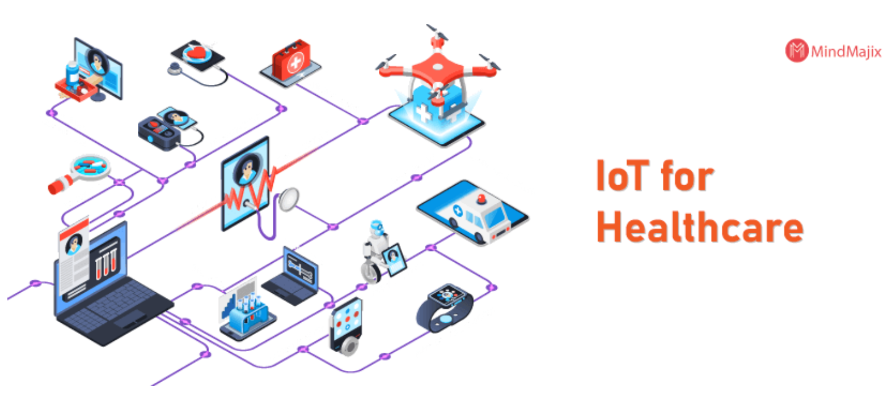

Figure 2: Healthcare (Source: Internet)

1. Review IoT functionality, standard architecture, frameworks, tools, hardware and APIs (P1-P2)
2. IoT architecture

IoT architecture refers to the tangle of components that comprise IoT networking systems, such as sensors, actuators, cloud services, Protocols, and layers. It is generally divided into layers that allow administrators to evaluate, monitor, and maintain the system's integrity.

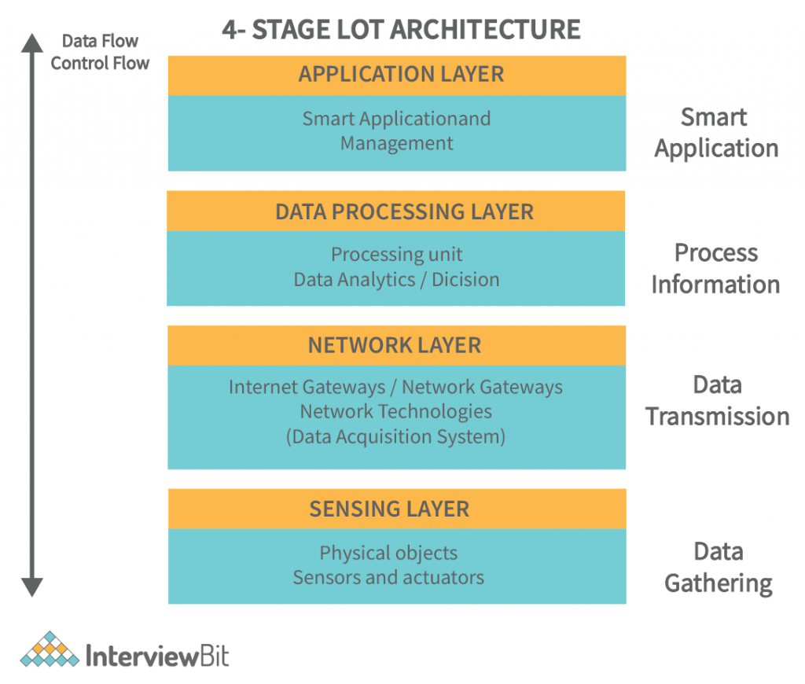

Figure 3: Stage lot architecture

* Perception/Sensing layer: The first layer of any IoT system consists of "things" or endpoint devices that act as a bridge between the physical and digital worlds. The physical layer, which includes sensors and actuators capable of collecting, accepting, and processing data over the network, is referred to as perception. Sensors and actuators can be linked wirelessly or through wired connections. The architecture does not restrict the scope or location of its components.
* Network layer: The network layers show how data is moved throughout the application. Data Acquiring Systems (DAS) and Internet/Network gateways are included in this layer. A DAS is responsible for data aggregation and conversion (collecting and aggregating data from sensors, then converting analog data to digital data, etc.). The data collected by the sensor devices must be transmitted and processed. That is exactly what the network layer does. It enables these devices to communicate with other servers, smart devices, and network devices. It also manages all data transmissions for the devices.
* Processing layer: The processing layer is the IoT ecosystem's brain. Data is typically analyzed, pre-processed, and stored here before being sent to the data center, where it is accessed by software applications that monitor and manage the data as well as prepare subsequent actions. This is where edge IT or edge analytics come into play.
* Application layer: User interaction occurs at the application layer, which provides the user with application-specific services. A smart home application where users can turn on a coffee maker by tapping a button in an app or a dashboard that displays the status of the devices in a system are two examples. The Internet of Things can be deployed in a variety of ways, including smart cities, smart homes, and smart health.

(interviewbit.com/, 2022)

1. IoT frameworks

The Internet of Things (IoT) Framework is an ecosystem made up of several connected devices that communicate with one another via the Internet. These networked devices typically transfer and sense data over the Internet with minimal human intervention.

The IoT framework is what allows connected devices to communicate with one another over the Internet. It's no surprise, then, that it's known as the 'Internet of Things' framework, or the framework that enables the interaction of 'Things' (devices) over the Internet.

The Internet of Things framework is a critical component of modern technology, with applications in almost every industry. One of the most important IoT applications is in the design of smart homes.

(IoTDunia, 2022)

IoT frameworks include the following:

* Amazon Web Services (AWS) IoT: This is a web service platform created by Amazon that allows smart devices to connect to the cloud or to other devices securely and quickly.
* Arm Mbed IoT: Mber platform is a platform that integrates many special features. In which, Mber provides a wide and secure environment for interconnected devices, thereby promoting IoT development.
* Microsoft Azure IoT Suite: The services from this platform help users to do all the activities like interacting, receiving data, analyzing, converting… from their IoT devices.
* Google’s Brillo/Weave and Calvin: are also the platforms that play an important role in promoting the development of IoT.

(Gillis, 2022)

1. API

Although separate services in AWS such as IoT Core, Device Shadow, DynamoDB, etc. all provide methods for applications to connect and exchange data via APIs or SDKs, a complete IoT system is nevertheless requires tailoring a set of application layer APIs to a common standard so that applications can easily interact to ensure easy extensibility, inheritance, and maintenance of the system for future upgrades.

As API management company Axway [puts it](https://www.axway.com/en/enterprise-solutions/api-management/api-internet-of-things-iot), “APIs are tightly linked with IoT because they allow you to securely expose connected devices to customers, go-to-market channels and other applications in your IT infrastructure.”

(Hill, 2022)

1. IoT tools

Internet of Things Tools is an abbreviation for Internet of Things Tools. It is a network or link that includes, among other things, gadgets, cars, equipment with embedded electronics, household appliances, and buildings. This facilitates the collection and exchange of various types of data. It also allows the user to control the devices remotely via a network.

1. IoT hardware

IoT Hardware includes a wide range of devices such as routing devices, bridges, sensors, and so on. These Internet of Things devices handle critical tasks and functions such as system activation, security, action specifications, communication, and detection of support-specific goals and actions.

IoT Low-power boards; single-board processors such as the Arduino Uno, which are basically smaller boards that plug into mainboards to improve and increase functionality by bringing out specific functions or features (such as GPS, light and heat sensors, or interactive displays).

(data-flair.training, 2022)

# Task 2 – A specific program to solve using IoT

1. Problem

Currently, in the educational environment, ensuring security is very necessary for students to be able to go to school with peace of mind. But security in schools is quite lax and face scanning system has been deployed and it is extremely necessary for schools. At the same time, this device will take attendance to record students' entry and exit times for instruction teachers can be caught.

1. Solution

Therefore, the face attendance system is very necessary. Facial recognition solutions are compatible with security software. The facial recognition process only takes 1s, which is very beneficial for educational institutions. Nowadays, cyber attacks, advanced hacks, companies need safety and fast. Facial recognition allows to identify a person's identity efficiently and quickly and ensure security while at school. this can save time, no need to expose the device like fingerprints or other security measures...

Based on IoT technology, face recognition was developed to solve this problem. Once a student has registered, it will display a square with the student's name, which indicates that the student has successfully registered the face. And when the face is detected, it will be saved as excel and stored in the computer.

1. Components

**ESP32-CAM:** The ESP32-CAM is a small camera module that costs around $10 and uses the ESP32-S chip. It has a microSD card slot for storing images taken with the camera or files to serve to clients, in addition to the OV2640 camera and several GPIOs for connecting peripherals.

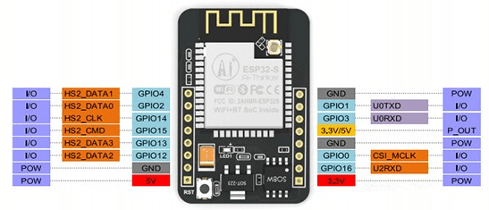

Figure 4: ESP32-CAM

Here is a list with the ESP32-CAM features:

* The smallest 802.11b/g/n Wi-Fi BT SoC module
* Low power 32-bit CPU, can also serve the application processor
* Up to 160MHz clock speed, summary computing power up to 600 DMIPS
* Built-in 520 KB SRAM, external 4MPSRAM
* Supports UART/SPI/I2C/PWM/ADC/DAC
* Support OV2640 and OV7670 cameras, built-in flash lamp
* Support image WiFi upload
* Support TF card
* Supports multiple sleep modes
* Embedded Lwip and FreeRTOS
* Supports STA/AP/STA+AP operation mode
* Support Smart Config/AirKiss technology
* Support for serial port local and remote firmware upgrades (FOTA)

**Camera module OV2640 - V1:** is a popular electronic component that works with the ESP32 module to receive the "take photo" command, take a picture and save it to memory, and then display it. Using the browser, display the newly captured image on the computer connected to the ESP32 board.

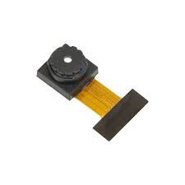

Figure 5: Camera module OV2640-V1

**FTDI Programmer:** The FT232RL USB to TTL 3.3V/5V FTDI Serial Adapter Module is a widely used module for connecting a TTL serial communicating device to a PC via a USB mini port. The jumper on the board allows you to select different output voltage options for this converter module. Any legacy peripheral can be upgraded to USB using the FT232RL USB to TTL Serial Adapter Module.

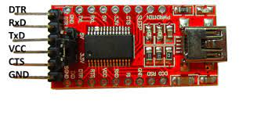

Figure 6: FTDI

This section mentions some of the features and specifications of the FT232RL USBto TTL Converter:

* Operating Voltage: 5V/3.3V DC
* Max Current Draw: 5V - 500mA; 3.3V - 50mA
* Connector: Mini USB
* Fully integrated 1024-bit EEPROM storing device descriptors and CBUS I/O configuration
* Data transfer rates from 300 baud to 3 Mbaud (RS422, RS485, RS232) at TTL levels
* 128 byte receive buffer and 256 bytes transmit buffer
* Transmit and receive LED drive signals
* Fully integrated clock generation with no external crystal required

# Conclusion

Through the above report, we have learned more about the definitions and information related to the IoT field. In addition, a problem was created for the writer to discuss and find solutions according to IoT.

# References

analyticsvidhya.com, 2022. *10 Real World Applications of Internet of Things (IoT) – Explained in Videos.* [Online]   
Available at: https://www.analyticsvidhya.com/blog/2016/08/10-youtube-videos-explaining-the-real-world-applications-of-internet-of-things-iot/

data-flair.training, 2022. *IoT Hardware | IoT Software – A Complete Tour.* [Online]   
Available at: https://data-flair.training/blogs/iot-hardware/

Gillis, A. S., 2022. *What is the internet of things (IoT)?.* [Online]   
Available at: https://www.techtarget.com/iotagenda/definition/Internet-of-Things-IoT

Hill, K., 2022. *What is an IoT API?.* [Online]   
Available at: https://www.rcrwireless.com/20161018/featured/what-is-an-iot-api-tag6-tag99

interviewbit.com/, 2022. *IoT Architecture – Detailed Explanation.* [Online]   
Available at: https://www.interviewbit.com/blog/iot-architecture/#:~:text=IoT%20architecture%20refers%20to%20the,the%20integrity%20of%20the%20system.

IoTDunia, 2022. *What is IoT framework? List top 10 Open source IoT frameworks.* [Online]   
Available at: https://iotdunia.com/what-is-iot-framework-list-top-10-open-source-iot-frameworks/

i-scoop.eu, 2022. *What is IoT? The Internet of Things defined and explained.* [Online]   
Available at: https://www.i-scoop.eu/internet-of-things-iot/internet-of-things-what-definition/